Ten things Autism isn’t…

Published by Rhi
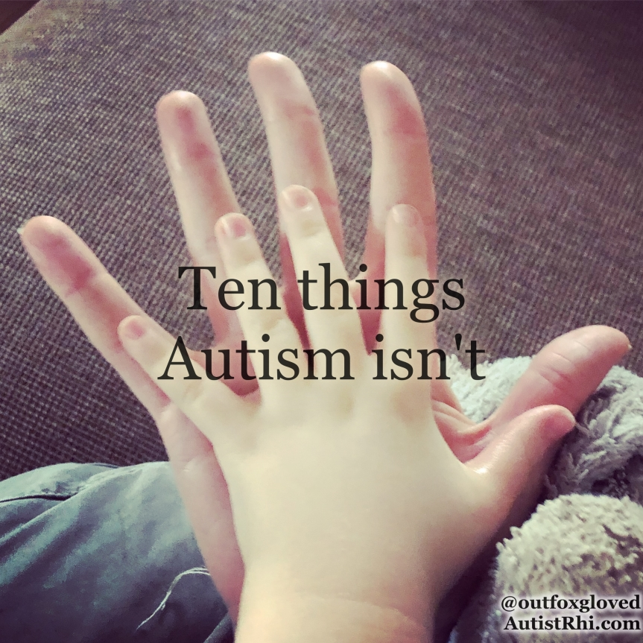
I was going to write about what autism is, but as I wrote it transmogrified into what autism isn’t, so here is my list of what autism is not:-

1. Autism is not being socially awkward
It’s not awkwardness. Autistic people are often excellent at socialising with each other, where they can avoid eye contact, stim, avoid small talk, share information and rely on their own natural communication preferences.
We don’t do social communication automatically, and by that I mean we don’t do non-autistic social communication automatically, because I have never seen anyone express happiness more effusively than an autistic person meeting someone else with the same interests and sharing their joy.

2. Autism is not avoiding eye contact
For some autistic people eye contact is overwhelming and painful, for others it’s not a problem. I have lost count of the number of people who have gone for a diagnosis and been told they don’t meet the criteria as they are making eye contact.
I myself tend to look at the bridge of the nose or the mouth. I lip-read a lot when people speak so that my visual processor can support my auditory processor and I’m more likely to work out what it is you are saying.
I had assumed that eye contact was a euphemism for looking at someone’s face. Imagine my surprise when I was told that people actually look into the eyes directly and that this was a sign of honesty and dependability. How I laughed at the strange world of non-autistic communication and its illogical rules.

3. Autism is not lacking empathy
This is probably the big one for me, because it is the reason that I didn’t seek a diagnosis for years. I worked with autistic teens, I had all these sensory difficulties and executive function issues, all these social misunderstandings and miscommunications, all these social hangovers that would take weeks to pass, all these similarities, but how could I be autistic? I was married with children, I had friends, I cared deeply about lots of people; wasn’t autism supposed to be synonymous with cold and unfeeling and selfish?
No, it never was. We were fed lies and stereotypes by the media. Some autistic people do lack empathy – as do many non-autistic people – but it’s not a given. What we do tend to do is to perform our feelings differently or appear to be cold and distant when we are feeling overwhelmed. This is a miscommunication not a lack of feeling.
Many autistic people report hyper-empathy as a problem; feeling empathy more strongly than the average person. We are as caring and loving as any other group of people.

4. Autistic people do not lack imagination
Difficulties with social imagination are a thing, but that does not translate into a lack of imagination generally. We are a creative bunch. Pattern-thinking is one of my favourite things about being autistic; I see patterns and connections in everything and I use this to inform my creativity. I may be a bit rubbish at applying a creative social story to some green arrows on a screen, but I’m great at imagining the connections that run through us all in every aspect of our lives.
What is imagination anyway? Some people think in words, others in pictures, others in a mixture. Is imagination simply thinking about something as it isn’t? Creativity is enormously important for many autistic people, we feel it as a deep need, and it is not possible to create without imagination.
I start to get twitchy if a few days go by and I haven’t made something new. The form doesn’t matter, it could be writing, origami, chainsawing, woodwork, design, DIY, crochet, spreadsheets, sewing, gardening or just generalised hitting something with a hammer until it forms into what I want it to; creativity is a drive that has imagination at its roots.

5. Autism is not black and white thinking
Okay, so this one is a tricky one; I am definitely a black and white thinker, I definitely have rigid behaviour patterns and I definitely hate change, but my black and white thinking is built on a foundation of research and analysis.
When someone says, “But have you considered..?” Yes. Yes I have. I’ve thought of every possible permutation I could come up with. Nothing I do is unplanned or baseless. But – and this where I argue that my black and white thinking is different – if someone showed me evidence to change my mind, I would.
I’ve noticed non-autistics are often emotionally attached to their opinions, to attack the view is a personal attack. To attack my view is to attack my ability to reason, but present me with additional information that refutes me and I will embrace it.
Yes, I am literal. I literally studied English Literature in University so that I could learn how to read between the lines. I’m good at it, but it’s all very conscious. One thing that often strikes me is how averse to change many non-autistics are when it comes to how things are done. It isn’t the autistic person fearing new technology, or wanting to do things in a certain way because “this is how we have always done it”. There is a different kind of rigidity to be found in the non-autistic population, that keeps us from making positive change when it is logically the best way forward. We all need a bit more flexibility in our thinking.

6. Autism is not a learning difficulty
About a third of autistic people have a learning difficulty too, and this can change their support needs significantly. Learning non-natural communication methods is particularly hard for those with learning difficulties. It is incredibly important that those who are not verbal have their needs supported and heard.
One way the rest of us can help is by sharing how autism affects us, so that we can all better understand the triggers for stress behaviours in those who cannot express the problem. When it comes to needs we will all need different things. I like to think of myself as not needing support, but I do have a husband who takes on things like going to the supermarket (which I find a nightmare due to sensory overload as well as executive function problems, the number of variables involved, and the possibility of unscripted social interactions with anyone I have ever met) and providing me with information about change and taking me to new places. My needs vary day to day, but I don’t have a learning difficulty, it is not the same thing as autism and it does create additional difficulties that need understanding.

7. Autistic people are not incapable of lying
I am an honest person. Lies make me uncomfortable and I am terrible at spotting when I’m being lied to (even when the lie is outrageous). I don’t like lying, it doesn’t come naturally to me.
Autistic people are generally honest and like clarity in communication. This can be seen negatively as blunt and rude, or positively as clear and honest, depending on your viewpoint. Social lies are something I have had to learn – when someone is asking if you like what they’re wearing and it’s too late to change, they are looking for affirmation, not a critique of their choice (though I’m unlikely to have strong feelings either way, fashion is not my forte).
Autistic people tend to be better at seeing things as they are, rather than seeing what we are socially expected to, and this comes down to the advantage of not processing social communication automatically – we don’t soak things in unconsciously, we make a choice to engage or not.
There are also some autistic people who do lie as a matter of course. This is often down to trying to avoid social confrontation and wanting to give someone exactly what they think that person wants to hear in order to fit in. It can be a real difficulty for some autistic people, especially because it often ends up distancing them from the people they are trying to get close to.

8. Autistic people are not impolite
We like rules and I am particularly partial to the very British manner of sprinkling pleases and thank-yous and sorrys through every sentence I speak. In Britain if you only say thank you once, you aren’t being grateful enough. We are a ridiculous nation. I was raised with strict Victorian ideals of politeness. Debrett’s would be more than happy with my etiquette.
When we talk about a lack of politeness we are usually talking about someone who is either bluntly crossing social boundaries they weren’t aware existed, or someone who has seen through the charade of empty words. Clarity and honesty is not rudeness.
If I say you are obese, because you meet the clinical criteria for obesity, then I am stating a fact and not making a judgement. Whether you are obese or not doesn’t make you a good person or a bad person, it doesn’t make you cruel or kind, it just is. But I know that most people would assume that stating that fact had been done as an insult, so I won’t say it. If I did, I would not be trying to be rude, I would not be trying to be insulting, I would just be stating a truth, and I would likely be misunderstood.
If I see that many people use formal-politeness to be passive-aggressively rude, and I decide to skip the formalities and just be kind, then again I would not be trying to be impolite, I would be skipping the garnish and going for the meaning beneath it instead.
Sorry.

9. Autistic people are not all good at maths
A tricky one for me, because I’m good at maths. I have a mind that loves logic puzzles and finding patterns, and numbers bring me great joy, but I am not all autistic people. Many autistic people don’t have that form of pattern thinking, they don’t find numbers easy, they are not logic-minded.
Extremely few autistic people are savants of any kind, even fewer are maths savants – we don’t get a superpower as a trade off for finding social communication hard. I’m good at maths, that doesn’t mean I can calculate pi to a hundred decimal places in my head, nor calculate vast sums without a calculator. There is huge variation between autistic people, if in doubt ask us about our interests, most of us would be happy to share!

10. Autistic people are not incapable of growing up
Most autistic people are adults. Some of us will require support throughout our lives. Many of us are parents, we work, we socialise, we are valuable members of our communities (look no further than fifteen year old Greta Thunberg who inspired the latest school-strikes to protest climate change, for a level of maturity far surpassing most adults), we care deeply about fairness, equality and we are not constrained by a fear of long term social change.
You’ll find us waiting at the school gates, in the office, in the art world, singing on a stage, dancing (badly but enthusiastically if you’re like me), paying bills, walking the dog on the beach, we’ve infiltrated everywhere.
I often rely on routine to overcome my difficulties keeping on top of day to day necessities. I use familiarity to breed my contempt… no, I use familiarity to keep me feeling safe, and I use my pattern thinking to predict what will happen and when, so that I do not get overwhelmed. I have noise cancelling headphones for when it gets too loud, dark glasses for when it gets too bright, and down time to recover when it all gets too much. As with all adulting, it’s about finding a balance that works, and joining in the biggest lie of all; that all adults know what they are doing.

Autism isn’t this strange alien thing, it’s just a different way of thinking and experiencing the world. Some of us will find ourselves more or less compatible with modern living than others, we will all have different needs (and those may vary day to day), but autism is not terrifying or awful, nor is it marvellous and fabulous, it just is.

It’s how I think and I wouldn’t be who I am without it.
Source: https://autistrhi.wordpress.com/2019/03/06/ten/

