The effects of stimulant dose and dosing strategy on treatment outcomes in attention-deficit/hyperactivity disorder in children and adolescents: a meta-analysis

Luis C. Farhat, José M. Flores, Emily Behling, Victor J. Avila-Quintero, Adam Lombroso, Samuele Cortese, Guilherme V. Polanczyk & Michael H. Bloch

Abstract
Clinical guidelines currently recommend practitioners titrate stimulant medications, i.e., methylphenidate (MPH) and amphetamines (AMP), to the dose that maximizes symptom control without eliciting intolerable adverse events (AEs) when treating attention-deficit/hyperactivity disorder (ADHD) in school-aged children/adolescents. However, robust evidence-base regarding the effects of doses and dosing strategies of stimulants on clinical outcomes in the treatment of children/adolescents with ADHD is currently lacking and stimulants are often underdosed in clinical practice. To address this gap and provide rigorous evidence-base in relation to the dose and dosing strategy of stimulants, we conducted the largest systematic review and dose–response meta-analysis examining change in ADHD symptoms (efficacy), and treatment discontinuations due to AEs (tolerability) and any reason (acceptability). We conducted one-stage random-effects dose–response meta-analyses examining MPH and AMP separately, stratifying trials based on fixed-dose and flexible-dose design. Daily doses of stimulants were converted to MPH- and AMP-equivalent doses by adjusting for different pharmacokinetics across formulations. We also conducted pairwise meta-analyses to provide indirect comparisons between flexible-dose versus fixed-dose trials. Our study included 65 RCTs involving 7 877 children/adolescents. Meta-analyses of fixed-dose trials for both MPH and AMP demonstrated increased efficacy and increased likelihood of discontinuation due to AEs with increasing doses of stimulants. The incremental benefits of stimulants in terms of efficacy decreased beyond 30 mg of MPH or 20 mg of AMP in fixed-dosed trials. In contrast, meta-analyses of flexible-dose trials for both MPH and AMP demonstrated increased efficacy and reduced likelihood of discontinuations for any reason with increasing stimulant doses. The incremental benefits of stimulants in terms of efficacy remained constant across the FDA-licensed dose range for MPH and AMP in flexible-dose trials. Our results suggest that flexible titration as needed, i.e., considering the presence of ADHD symptoms, and tolerated, i.e., considering the presence of dose-limiting AEs, to higher doses of stimulants is associated with both improved efficacy and acceptability because practitioners can increase/reduce doses based on control of ADHD symptoms/dose-limiting AEs. Although fixed-dose trials that are required by the FDA are valuable to characterize dose-dependency, they may underestimate the true potential benefit of trialing dose-increases of stimulants in clinical practice by not allowing dose adjustment based on response and tolerability. Additional research is required to investigate potential long-term effects of using high doses of stimulants in clinical practice.

Fig. 1: Dose–response curves for methylphenidate (panels A–C) and amphetamine (panels D–F) products.
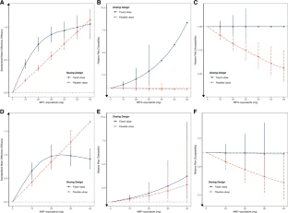

Fig. 2: Indirect comparisons of flexible-dose versus low fixed-dose studies.
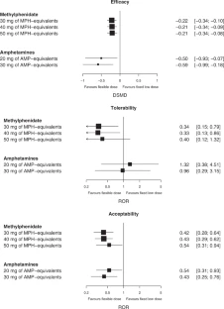

Author information

Affiliations
- Department of Psychiatry, Faculdade de Medicina FMUSP, Universidade de São Paulo, São Paulo, BR, Brazil
Luis C. Farhat & Guilherme V. Polanczyk
- Department of Psychiatry, Yale University School of Medicine, New Haven, CT, US
José M. Flores & Michael H. Bloch
- VA Connecticut Healthcare System, West Haven, CT, US
José M. Flores
- University of Connecticut School of Medicine, Farmington, CT, US
Emily Behling
- Yale Child Study Center, Yale University School of Medicine, New Haven, CT, US
Emily Behling, Victor J. Avila-Quintero, Adam Lombroso & Michael H. Bloch
- Center for Innovation in Mental Health – Developmental Lab, School of Psychology, Faculty of Environmental and Life Sciences, University of Southampton, Southampton, UK
Samuele Cortese
- Clinical and Experimental Sciences (CNS and Psychiatry), Faculty of Medicine, University of Southampton, Southampton, UK
Samuele Cortese
- Solent NHS Trust, Southampton, UK
Samuele Cortese
- Hassenfeld Children’s Hospital at NYU Langone, New York University Child Study Center, New York City, NY, US
Samuele Cortese
- Division of Psychiatry and Applied Psychology, School of Medicine, University of Nottingham, Nottingham, UK
Samuele Cortese
Source: https://www.nature.com/articles/s41380-021-01391-9

